GUIDE TO INSTALL KAFKA ON WINDOW

We need to download kafka-binary and not the source Download Binary from mirror URL: <http://mirrors.estointernet.in/apache/kafka/2.2.0/kafka_2.11-2.2.0.tgz> Version: kafka_2.11-2.2.0

Summary:

**Overview of Kafka**

[Apache Kafka](http://kafka.apache.org/) is an open source project for a distributed publish-subscribe messaging system rethought as a distributed commit log.

Kafka stores [messages](https://jaceklaskowski.gitbooks.io/apache-kafka/kafka-messages.html) in [topics](https://jaceklaskowski.gitbooks.io/apache-kafka/kafka-topics.html) that are [partitioned](https://jaceklaskowski.gitbooks.io/apache-kafka/kafka-topics.html#partitions) and replicated across multiple [brokers](https://jaceklaskowski.gitbooks.io/apache-kafka/kafka-brokers.html) in a cluster. [Producers](https://jaceklaskowski.gitbooks.io/apache-kafka/kafka-producers.html) send messages to topics from which [consumers](https://jaceklaskowski.gitbooks.io/apache-kafka/kafka-consumers.html) read.

**Step by steps**

**Step1**: download Kafka-runtime as above URL and then unzip proper destination path and folder on your server/laptop

For my case is

Window: e:\Apps\Kafka\kafka_2.11-2.2.0\ (*)

Linux: /u01/App/Kafka/kafka_2.11-2.2.0/

**Step2**: Create new directories in your Kafka directory

***Zookeeper***

***kafka-logs***

**Step3**: configure params in Kafka platform

Open both files below in Kafka-source folder accordingly e:\Apps\Kafka\kafka-2.3.0-src\config\

#3.1: modify content of ***zookeeper.properties***

***dataDir=e:\Apps\Kafka\kafka_2.11-2.2.0\zookeeper***

#3.2: modify content of ***server.properties***

*# Phongdo start add more params 2019*

***offsets.topic.num.partitions=1***

***offsets.topic.replication.factor=1***

***transaction.state.log.replication.factor=1***

***transaction.state.log.min.isr=1***

***min.insync.replicas=1***

***default.replication.factor=1***

*# Phongdo end add more params 2019*

**Step4:**  Start zookeeper server

In case I move to path and folder kafka be there on my machine ***e:\Apps\Kafka\kafka_2.11-2.2.0\***

*# Start/stop zookeeper server*

***zookeeper-server-start.bat e:\Apps\Kafka\kafka_2.11-2.2.0\config\zookeeper.properties***

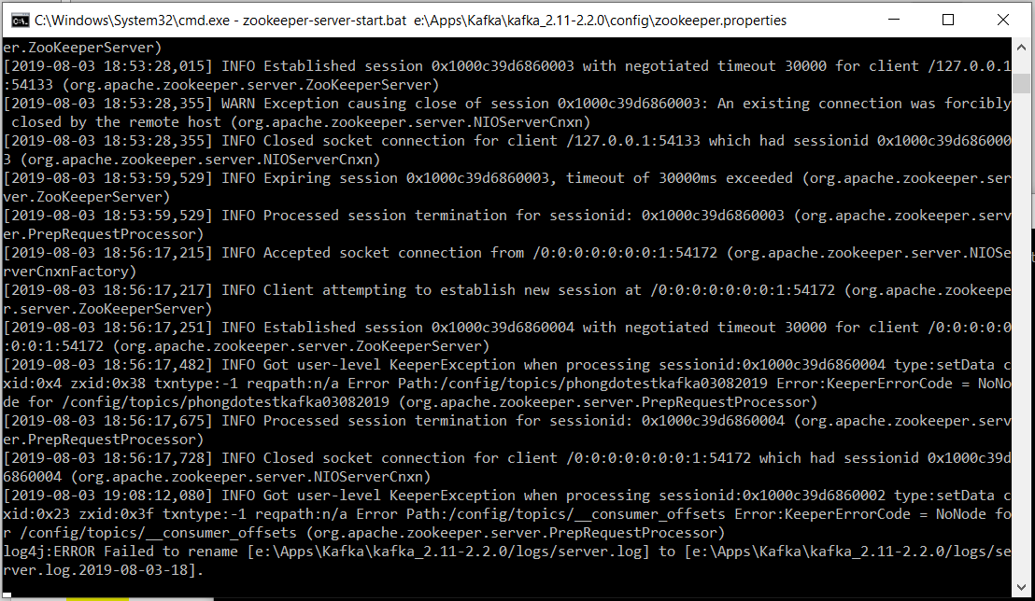

***zookeeper-server-stop.bat e:\Apps\Kafka\kafka_2.11-2.2.0\config\zookeeper.properties***

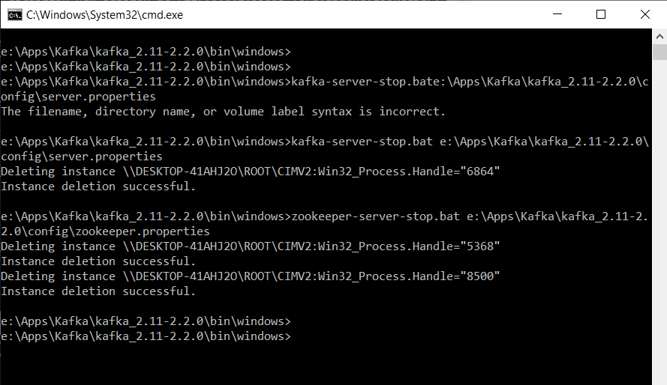

*# Start/stop Kafka server*

***kafka-server-start.bat e:\Apps\Kafka\kafka_2.11-2.2.0\config\server.properties***

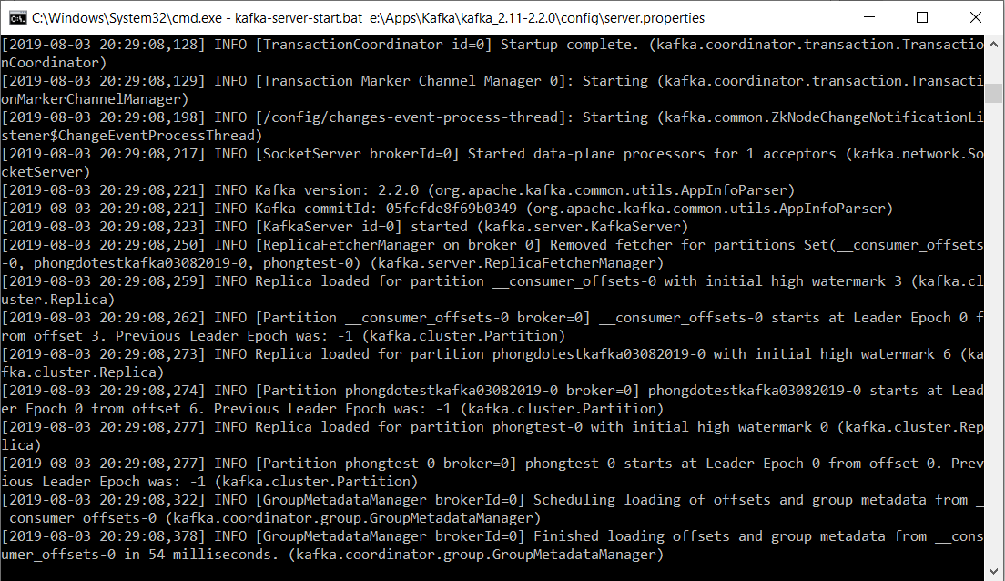

***kafka-server-stop.bat e:\Apps\Kafka\kafka_2.11-2.2.0\config\server.properties***

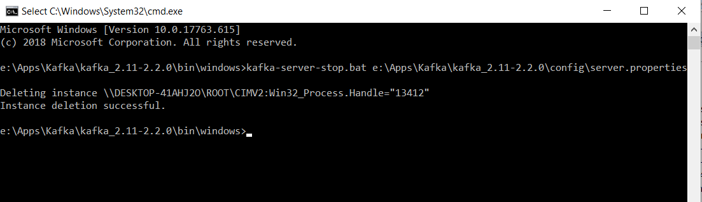

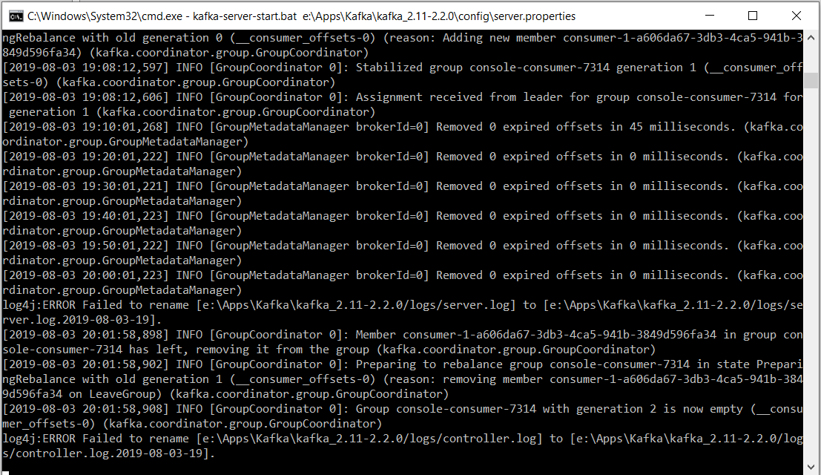

*# Initiate a node (for e.g localhost:2181) to create and handle brokers/ids*

**zookeeper-shell.bat localhost:2181 ls /brokers/ids**

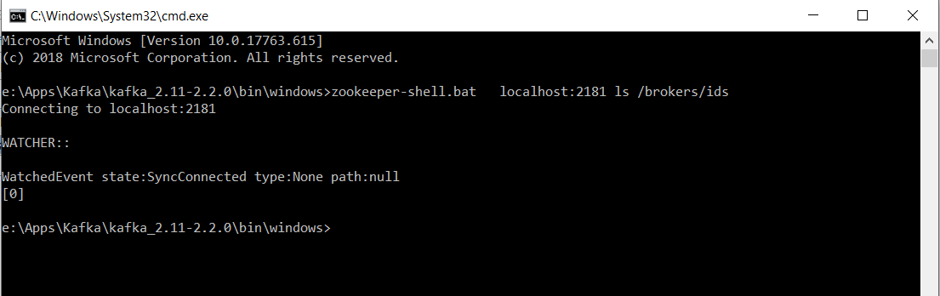

*#Create topics locate on partition 1*

***kafka-topics.bat --create --zookeeper localhost:2181 --replication-factor 1 --partitions 1 --topic phongtest***

***kafka-topics.bat --create --zookeeper localhost:2181 --replication-factor 1 --partitions 1 --topic phongdotestkafka03082019***

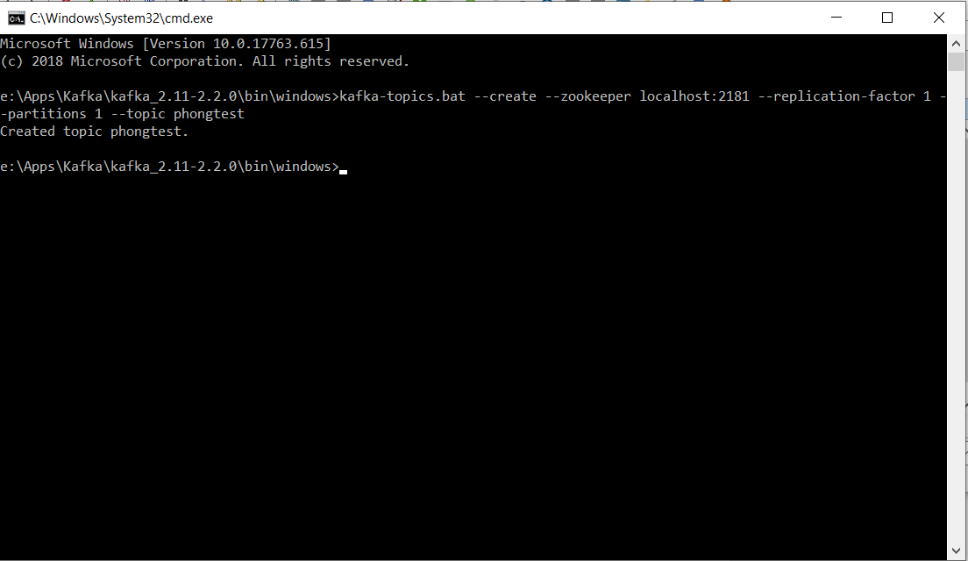

***e:\Apps\Kafka\kafka_2.11-2.2.0\bin\windows>kafka-topics.bat --create --zookeeper localhost:2181 --replication-factor 1 --partitions 1 --topic saxovntest1***

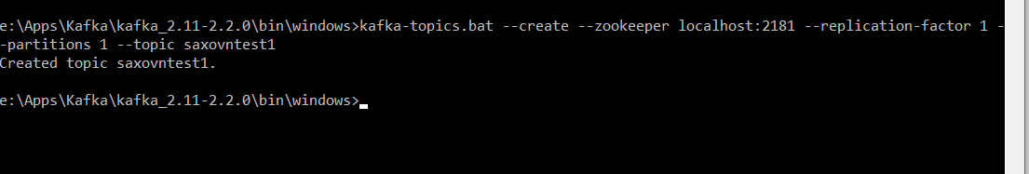

*# Issue messages*

***kafka-console-producer.bat --broker-list localhost:9092 --topic phongdotestkafka03082019***

*>hi Phong boss*

*>I'm your Kafka*

*>you created me by today at 6:59PM 03-AUG-2019*

*>I'm getting ready to assist you do something*

*>give me your command*

*>Thank you*

>*Ctrl+C ( in case you end )*

***kafka-console-producer.bat --broker-list localhost:9093 --topic saxovntest1***

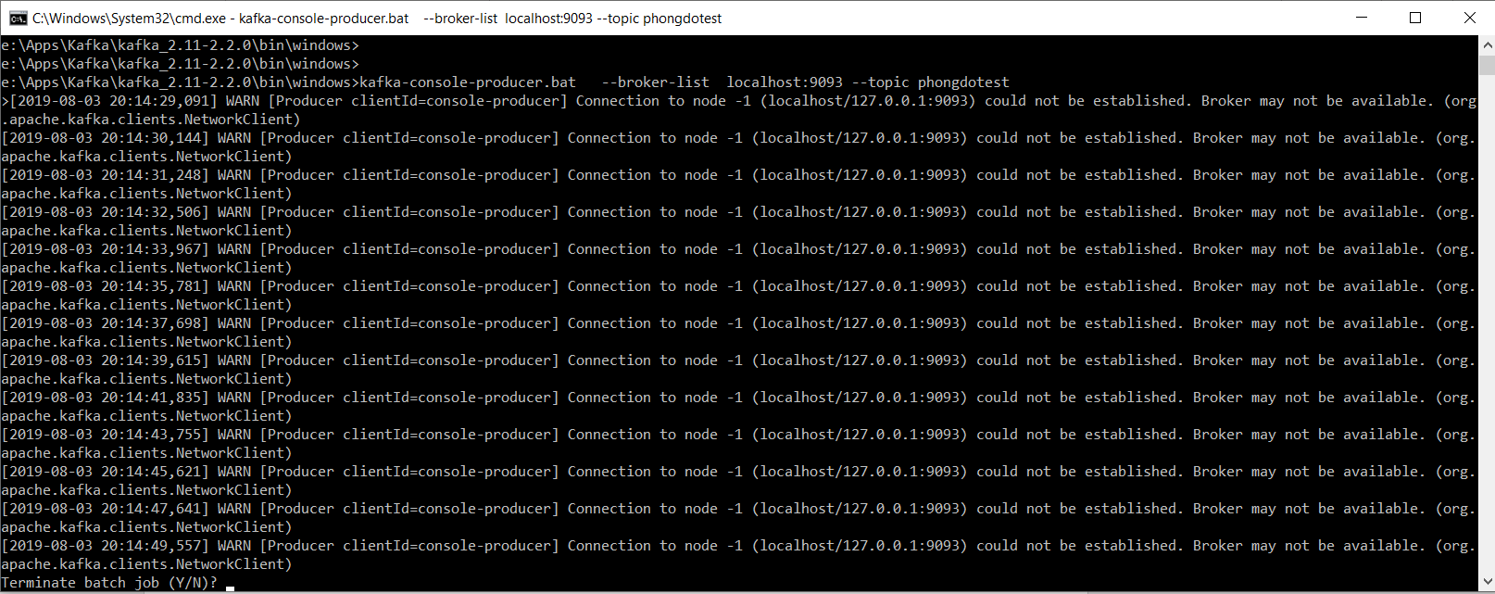

Again fix 9092 port

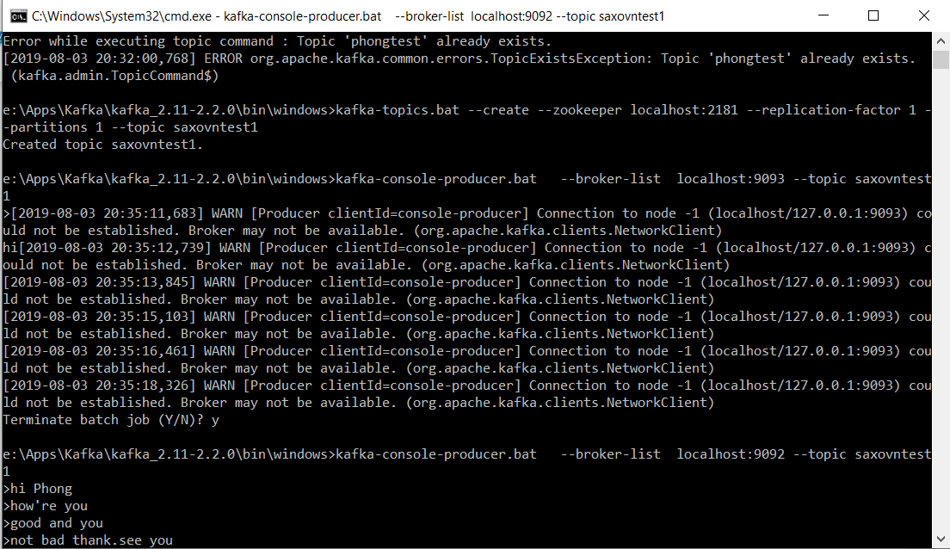

**Step5**: Create consumer where receive message from producer with topics 1

**kafka-console-consumer.bat --bootstrap-server localhost:9092 --topic phongdotestkafka03082019 --from-beginning**

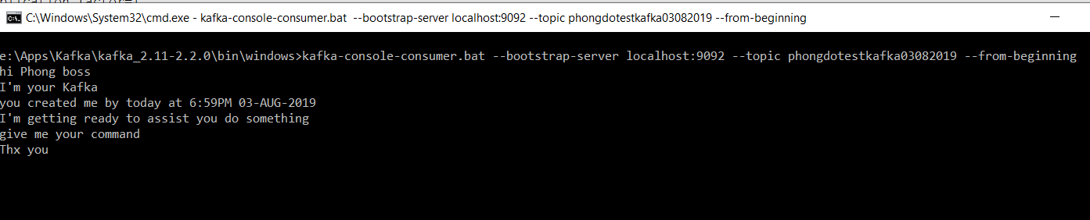

**kafka-console-consumer.bat --bootstrap-server localhost:9092 --topic saxovntest1 --from-beginning**

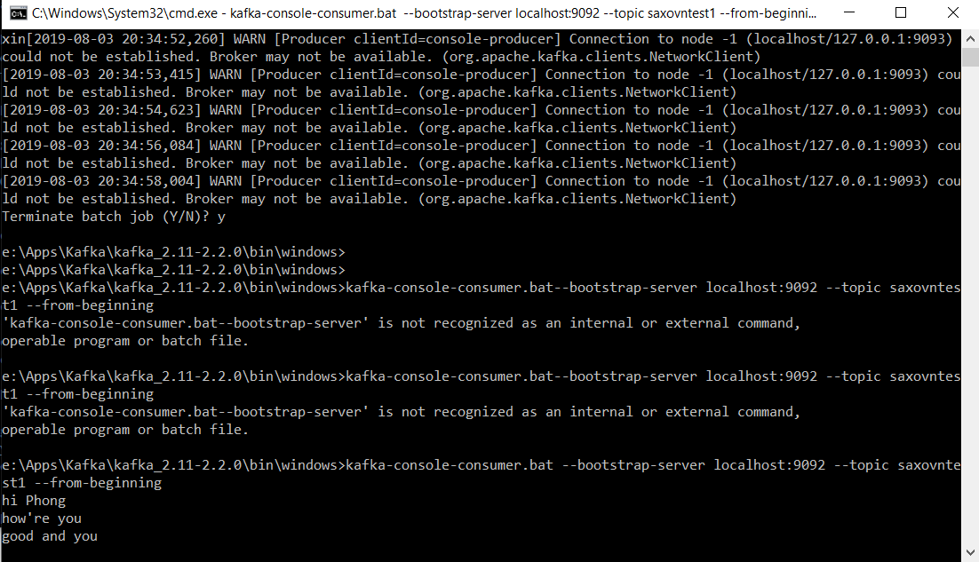

Summary:

